Analytics Report and Insights Documentation
Data Analyst Internship Task 5 of 6
Programme dates 10 October 2026 to 5 December 2026

Executive summary
The objective is to describe this cohort and assess whether baseline predictors can estimate a later progression score. The audited dataset contains 442 complete records. BMI is positively associated with the target, with correlation 0.586. Training cross-validation selected linear regression; final held-out MAE is 42.79. These results support a reproducible analytical benchmark, not an operational clinical tool.

Stakeholders and questions
The intended stakeholders are the internship evaluator and an analytical project reviewer. They need to understand data integrity, important associations, benchmark performance and the limits of recommendations. Questions include which predictors are associated with the target, whether modelling improves on a mean baseline, and which validation is required before broader use.

Key metrics
Source records 442; missing cells 0; duplicate records 0; target mean 152.13; target median 140.50; training records 353; test records 89. The target is a progression score and has no financial interpretation. Model results are documented alongside a reproducible train/test split.

Findings and interpretation
BMI has a positive sample association with progression, but substantial scatter prevents a deterministic interpretation. Other variables contribute information and may be related to each other. The mean score summarizes the cohort; it does not describe every subgroup. Model error shows why individual predictions need careful review.

Prioritized recommendations
Priority 1: maintain source provenance and automated audit checks before each rerun; acceptance criterion is a documented schema and quality summary. Priority 2: validate the selected model on an independent cohort before considering operational use; acceptance criterion is a prespecified error threshold agreed with domain experts. Priority 3: compare subgroup errors and investigate large residuals; acceptance criterion is a documented bias and error review.

Business impact and next steps
The immediate benefit is an auditable reporting process and evidence for further investigation. No financial savings, staffing change or treatment recommendation can be established from this dataset. Next steps are domain review, external validation, improved uncertainty assessment and a clear statement of acceptable use. The visualizations support communication but do not replace these checks.

References and reproducibility
https://scikit-learn.org/stable/modules/generated/sklearn.datasets.load_diabetes.html
Dataset notes and original study attribution are in data/SOURCE.md. The README explains setup, task mapping and submission. Report values are computed outputs, not proof of clinical validity.

Visual evidence
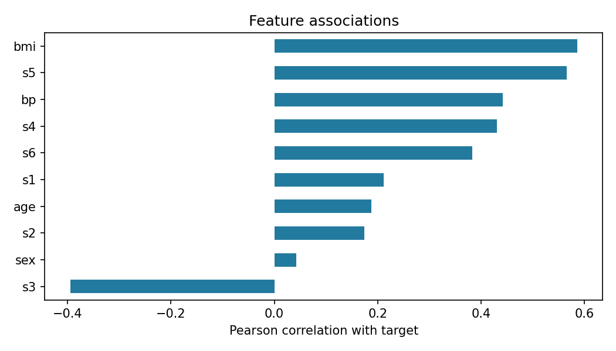
Feature associations help prioritize further investigation.

Computed evidence
Rows 442 Missing cells 0 Duplicate rows 0
Target mean 152.13 Target median 140.50
Complete tables and chart generation are available in outputs and src.

